Enhancement Three: Databases
Artifact: CS-360 Warehouse Inventory App
CS – 499 Capstone
Dylan Harmon
August 5, 2026
Artifact Description:
This artifact come from my CS-465: Full Stack Development I course. Travlr Getaways is a MEAN stack travel booking application. It has three parts that share one Express Server. A customer facing site rendered with Handlebars templates, a REST API backed by a MongoDB database, and an Angular single page application for admins to manage the trip catalog. The API protects its write endpoints with JSON Web Tokens, and passwords are stored with PBKDF2. I finished this artifact in June before starting this Capstone.
Justification for Inclusion:
I selected this artifact because it was full stack. It’s the only artifact I have with a fully functional database and API routes/controllers already in place. The original schema held only trips and users. Users existed only to gate access to the admin SPA. There were originally only three trips in the seed file. Queries included simple CRUD operations. The class was not focused on the complex database schemas so it offered me the perfect building blocks to expand upon.
I got to design a collection from nothing (Bookings), decide how it relates to what already existed, and then build the query layer that justifies those decisions. In my enhancement plan I stated that I wanted to work with aggregation pipelines and build a functional dashboard and this artifact was the perfect base for me to achieve that.

Four Part Enhancement:
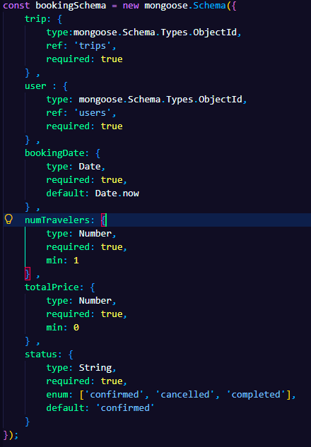
The first part is the booking collection:
Each booking stores a reference to a trip and a user as ObjectIds rather than embedding the trip document, along with a booking date, traveler count, and a status of confirmed, cancelled or completed. I also added three indexes: a compound index on trip and booking date, a single index on booking date, and one on status. Each of the indexes map to a specific aggregation pipeline.
I chose references because trip data changes. An Admin editing a trip through the Admin SPA would update the trips collection, and every embedded copy inside a booking would be out of date. Any query needing a readable trip name has to perform a $lookup, which is what makes the pipelines in this enhancement more involved. That is the data duplication against query complexity trade off that I mentioned demonstrating in my enhancement plan.
Total price was handled differently. It is calculated when the booking is created and stored on the document, rather than derived on read from the trip price and the traveler count. The Trip schema stores perPerson as a string however, summing strings in an aggregation does not produce a revenue figure, rather it is ignored. Storing the price as a Number at write time made every revenue calculation downstream correct and fast.
The second part is the seed data:
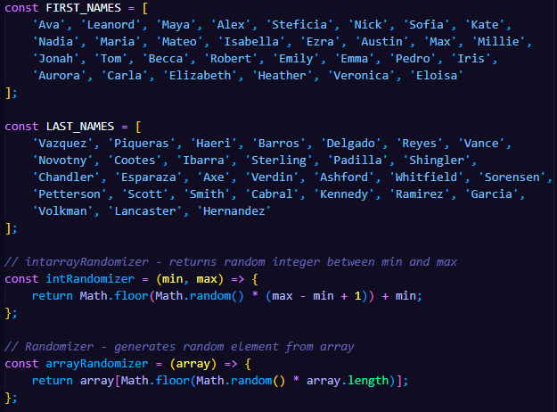
The collection needed records before it could be calculated. Two main parts are important to point out in bookingSeed.
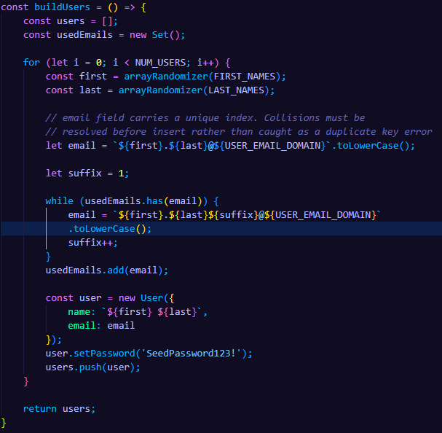

I created an array of First and Last names, and methods to return a random integer and an arrayRandomizer that returns an random item from the array. buildUsers generates users with emails that follow a standard format first.last.@travlrseed.test.
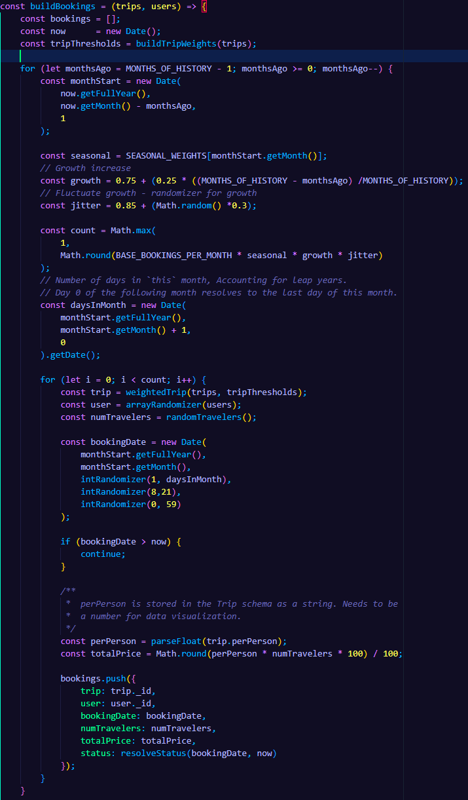The buildBookings generator walks backwards one month at a time from the current date (goes back 18 months MONTHS_OF_HISTORY). For each month it calculates how many bookings that month should hold by multiplying a base volume (BASE_BOOKINGS_PER_MONTH) against three factors – a seasonal weight indexed by calendar month, a growth factor, and a small jitter to include randomization in the curve. Within each month, individual dates are drawn against the actual number of days in that month, which I calculated by asking for day zero of the following month. JavaScript resolves that to the last day of the current one, and accounts for leap years without a special case. Any data that lands past the present moment (at generation) is discarded. Each booking then selects a trip through the weighted picker, draws a party size from a weighted distribution that favors solo and couple bookings over larger party sizes, and computes its total price by parsing the trip’s `perPerson` string and multiplying it by the traveler count. Status in buildBookings is done last: a cancellation is drawn at random against a configured rate (CANCELLATION_RATE), and every remaining booking resolves to completed or confirmed based on how long ago it was placed. A booking from fourteen months ago sitting in a confirmed state would be a data defect visible on the dashboard, and the doughnut chart would show an unreal status distribution.
Although the data is synthetic I wanted to try and make sure it was randomized enough that the data visualization dashboard was more reminiscent of a real travel booking agency. In addition to the seed data I added some more trips to the catalog. I used copyright free images from unsplash.com for the trip card and wrote generic descriptions to fill out the trip data.
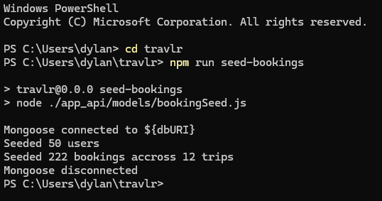
Part three is Data Aggregation:
This one is more difficult to include images so I will reference the specific methods by name. In my app_api/controllers we have the dashboard.js controller which stores the 4 aggregation pipelines used to generate the data queries used in our charts. Each pipeline is exposed as a protected GET endpoint under /api/dashboard.
revenueByTrip: In the revenue by trip pipeline, the $group runs before the $lookup, so the join executes once per trip rather than once per booking (12 trips vs. 225 bookings). The $lookup returns an array even when joining on a unique key, so a $unwind flattens it before the $project stage reshapes the result into the flat structure used in the charting layer. Average booking value is derived in that projection with $divide rather than stored, since it is a ratio of two values the pipeline already has.
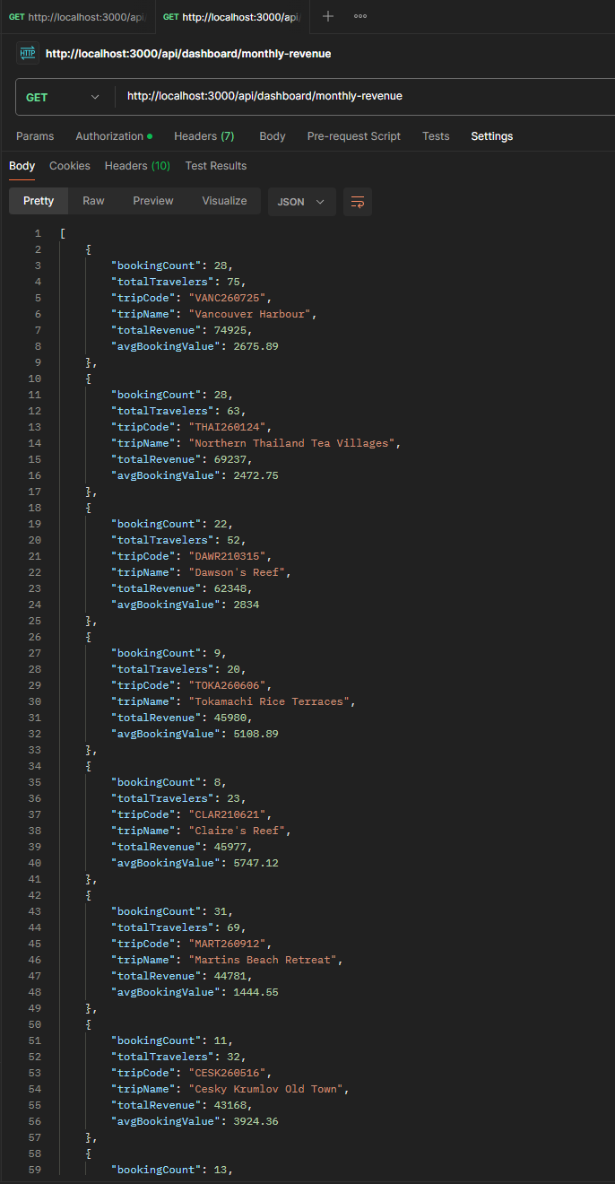
Postman test – revenueByTrips
monthlyRevenue: The trailing 12 month window is bounded in the $match stage rather than filtered after grouping, so months outside the range never enter the pipeline. Grouping uses $dateToString to format the booking date in to a YYYY-MM string, which sorts correctly as a string because that format lexicographically ordered the same way it is chronologically ordered. I set an explicit reporting timezone (my current timezone). Booking dates are written as local times but stored by MongoDB as UTC, so without it a booking placed late on the last evening of a month would be placed in the bucket for the following month.
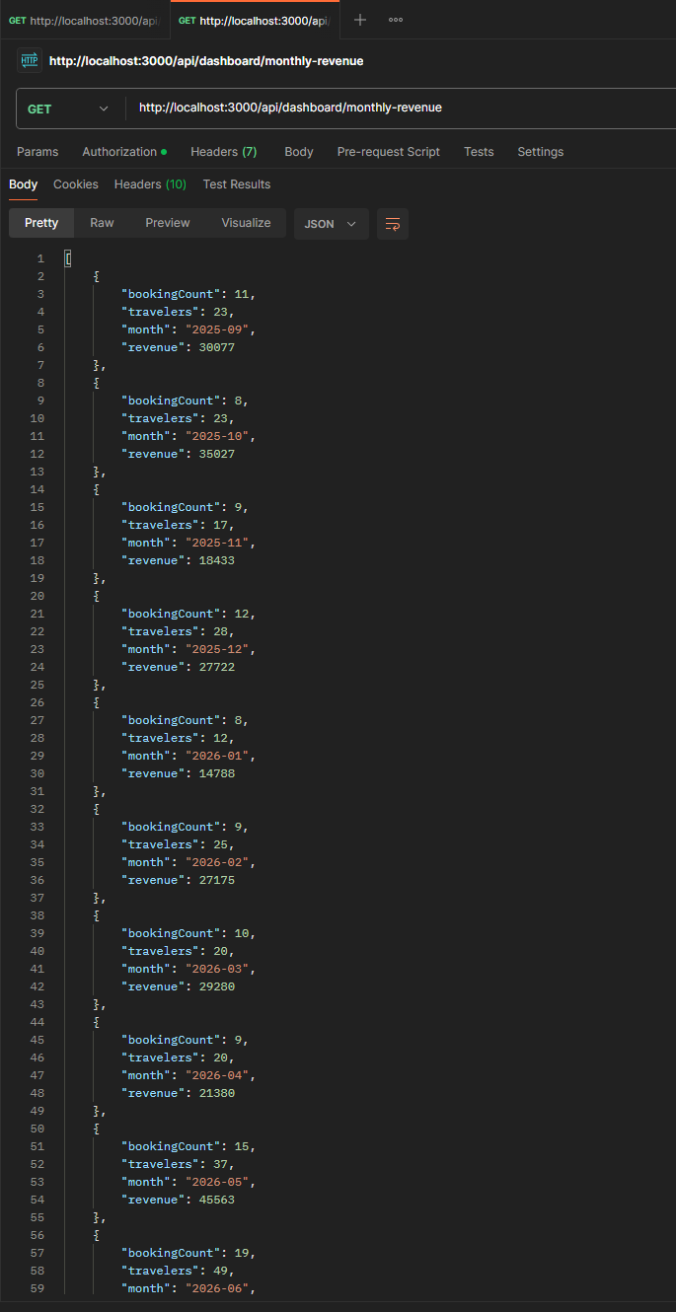
Postman test - monthlyRevenue
topTrips: This pipeline ranks on booking count rather than revenue to show the most popular trips. The $sort and $limit both run before the $lookup, so that only the five surviving documents get their trip details resolved rather than all twelve trips.
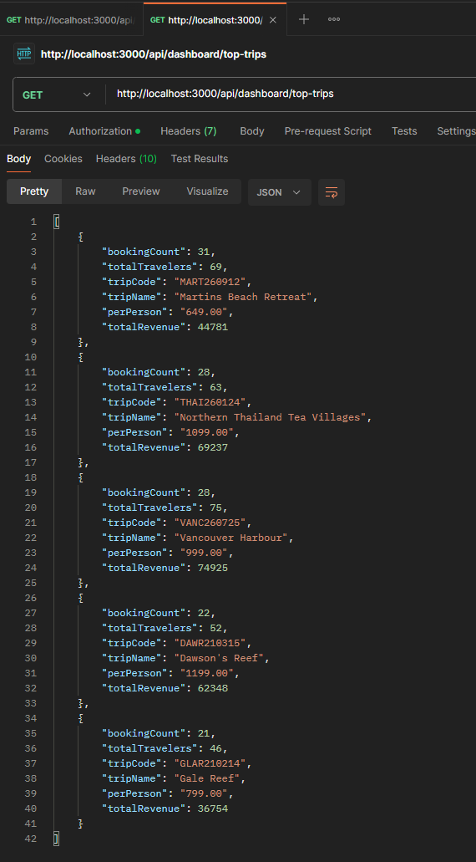
Postman test - topTrips
cancellationRate: Unlike the other three, this pipeline includes cancelled bookings, all the other pipelines exclude cancelled bookings since their revenue is lost and a cancelled trip shouldn’t be included in the count for most popular trips. It groups on a literal null to collapse the entire collection into a single document, then uses $cond inside each accumulator to count one status by adding 1 when the condition matches and 0 otherwise. Every figure, including revenue lost to cancellations, comes out of one pass instead of grouping by status and post processing the result set. The rate itself is guarded with $cond against an empty collection, so an unseeded database reports zero rather than failing on a division by zero.
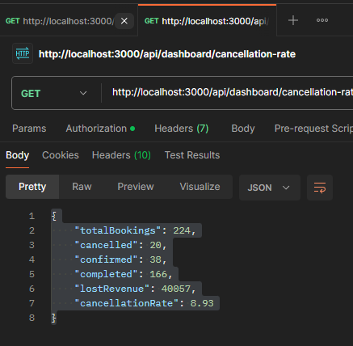
Postman test – cancellationRate

Part Four: Angular Dashboard Component
A separate DashboardDataService handles the four calls, a set of TS interfaces declares the shape of each response, and a standalone component renders four Chart.js visualizations against canvas elements queries through @ViewChild. I chose chart types to match what each metric is: A vertical bar chart for revenue by trip, a line graph chart for the monthly trend, a horizontal bar chart for the top five and a doughnut for the status breakdown. Below the charts is a table of the same revenue figures.
Why Chart.js?
Popularity was the deciding factor in my decision to use Chart.js. It seemed that Chart.js was the charting library that came up the most when scrolling Medium and my general google searches. MonogoDB has it’s own charting (MongoDB Charts), however it cannot join across different collections. Each visualization in MongoDB draws from a single collection. Every dashboard metric I had planned, except cancellation rate, requires a $lookup into trips to resolve and ObjectId into a readable name. Chart.js was simple to implement because it is a plain JavaScript library instantiated against a canvas element, so it fits standalone components (Angular Components) without an adapter. In my sources I have references to chartjs.org and their GitHub repo. Most of my reading in those resources included how to implement the different chart types.
Course Outcomes
In my enhancement plan I outlined three outcomes that would be displayed within this enhancement, and I believe I have met all three.
Outcome 1: Employ strategies for building collaborative environments that enable diverse audiences to support organizational decision making in the field of computer science.
The dashboard specifically is what meets this outcome. The bookings collection holds 222 documents that a non-technical stakeholder would struggle to decipher. The aggregation layer turns that into five figures and four charts that someone in sale or leadership can read without knowing what went into creating them. Below I am including a screenshot of the finished dashboard.
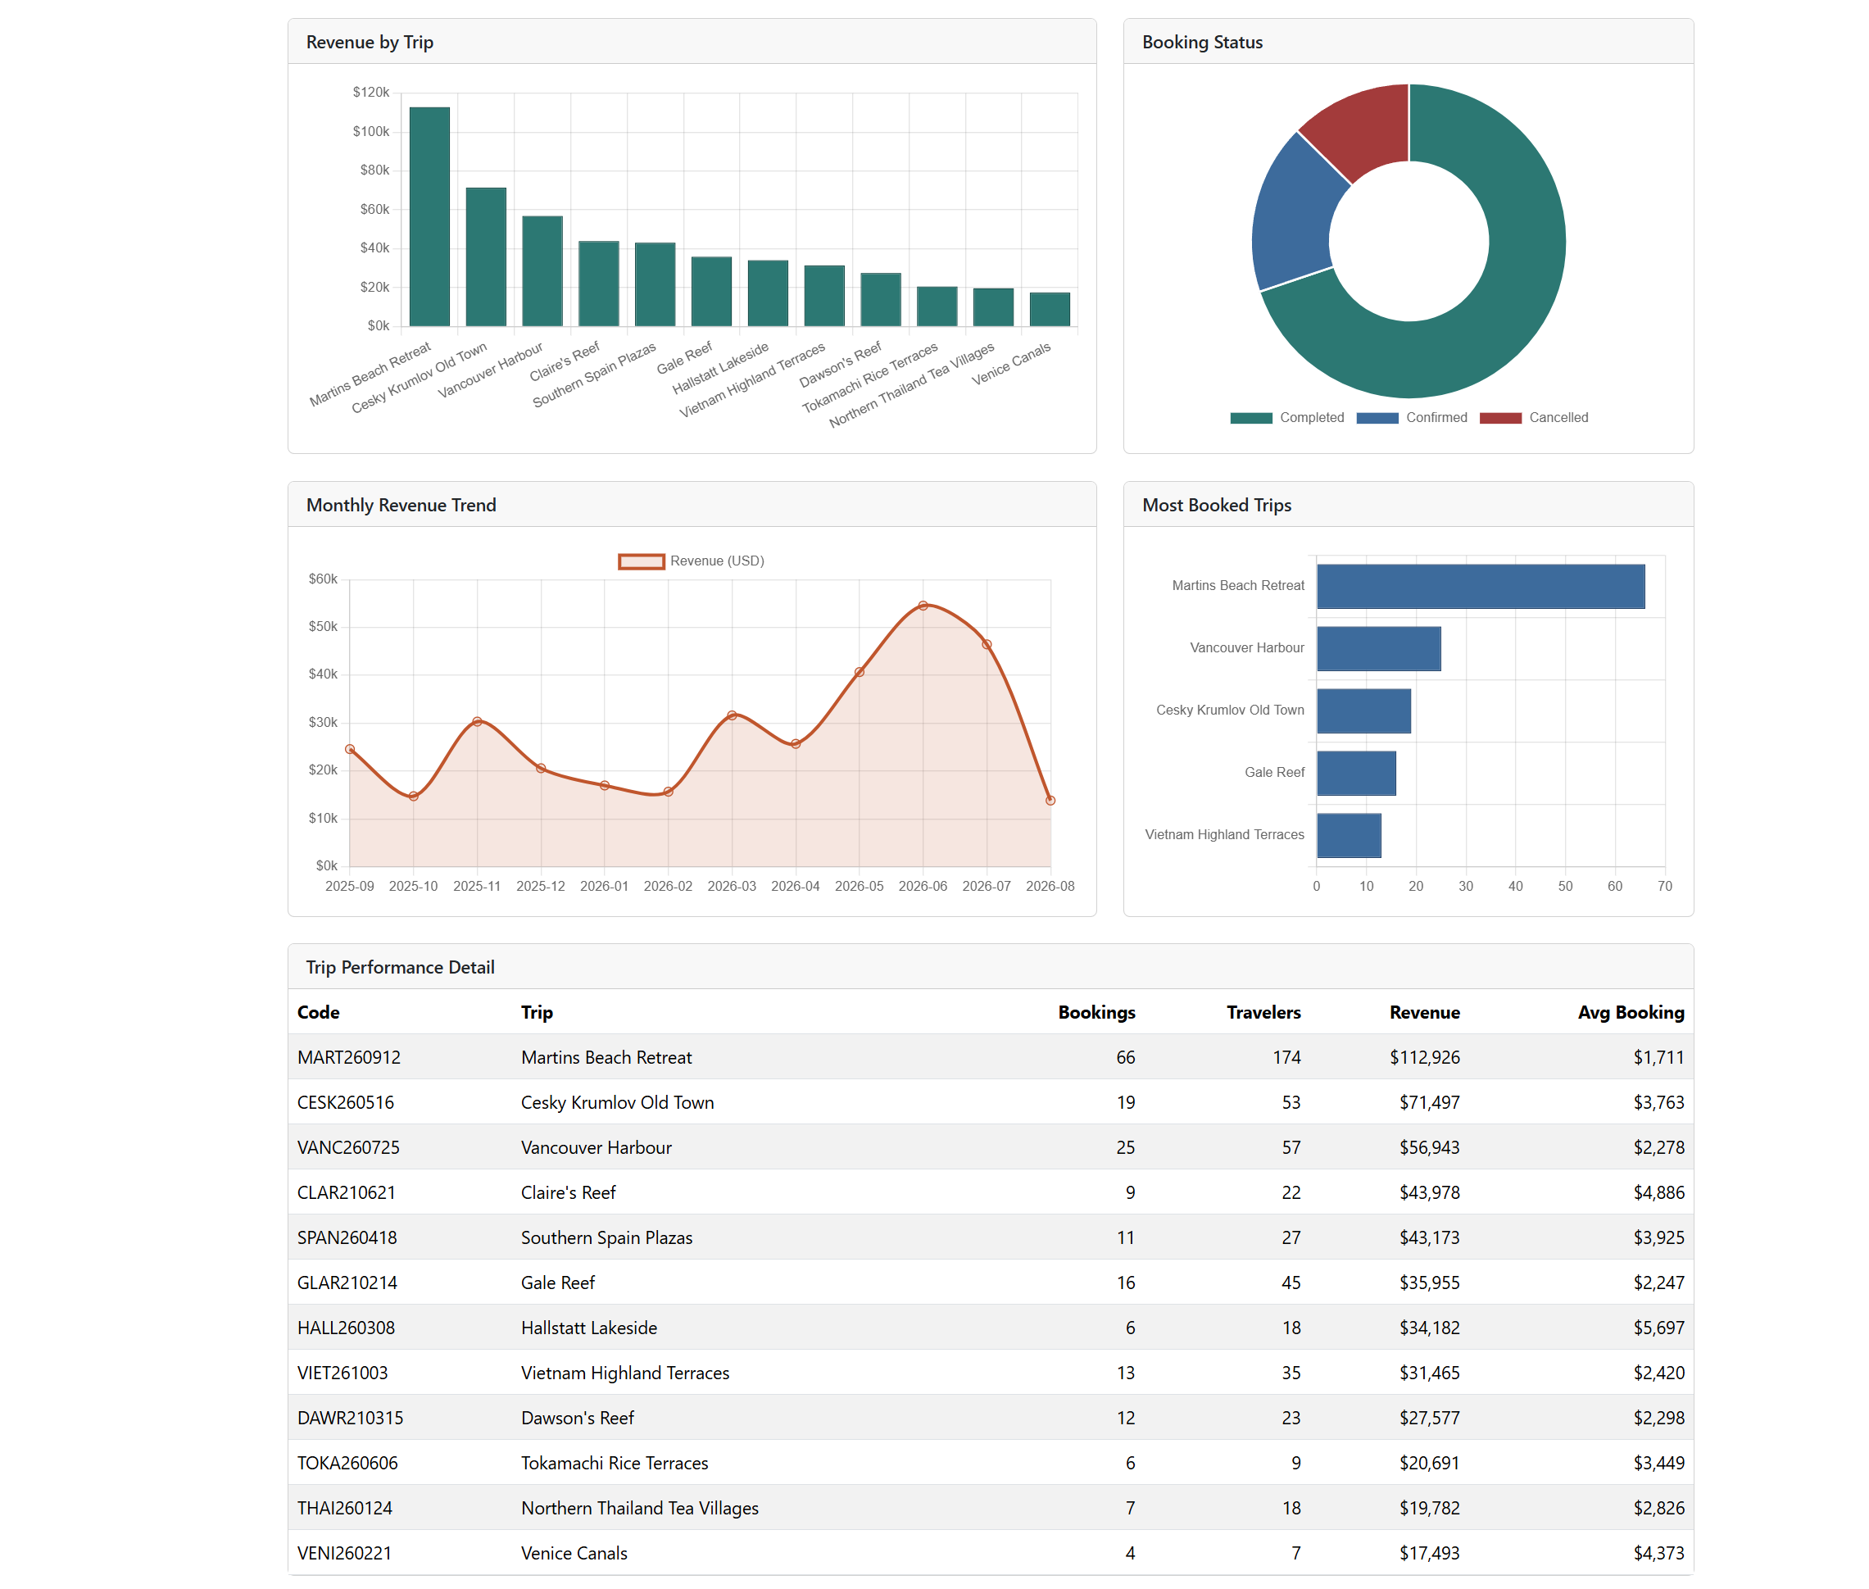

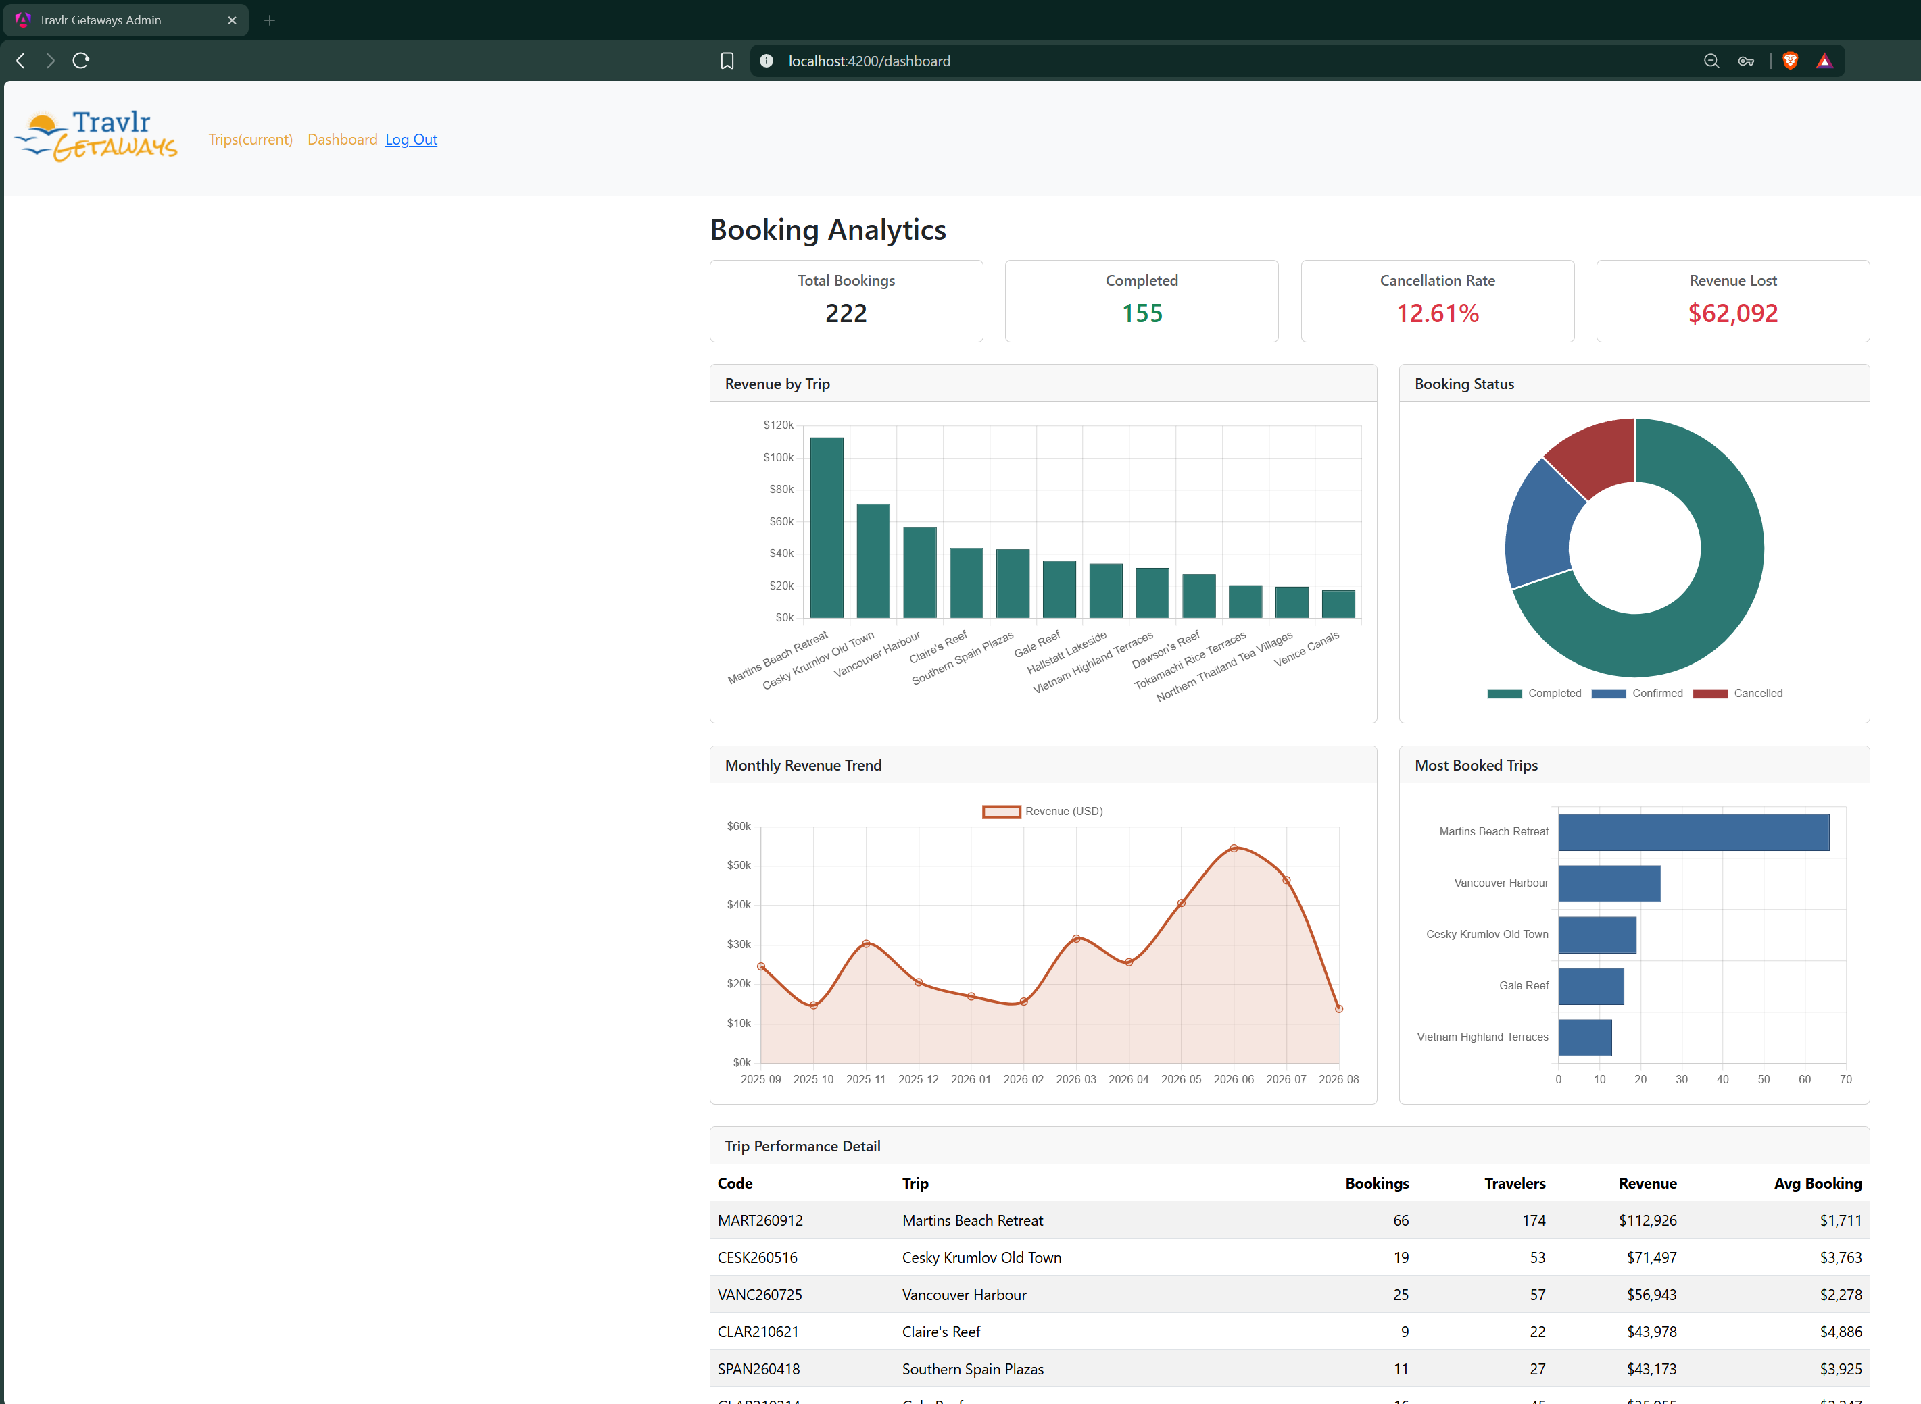

Outcome Two: Design, develop, and deliver professional-quality oral, written, and visual communications that are coherent, technically sound, and appropriately adapted to specific audiences and contexts.
The outcome was met specifically in the visuals displayed in the dashboard. Chart type selection was deliberate in each of the 4 cases. The top trips chart uses a horizontal orientation because it visually matches reading the trip name (left to right). Currency values on the axes are abbreviated to thousands. The four summary cards sit above the charts because a reader wants the “headline” to the key values first before looking at the distribution. The detail table exists because a chart deliberately discards precision in exchange for visualization, so the exact figures should exist somewhere in the dashboard for a user to access. One error that needs to be fixed can be found in the Monthly Revenue Trend. Since it is the beginning of a new month, the trend line dips, what I should have included was that the trend data end at the end of the last month. That way the trend wouldn’t dip so harshly as it does, representing a loss that really is not there.

Outcome Four: Demonstrate an ability to use well-founded and innovative techniques, skills, and tools in computing practices for the purpose of implementing computer solutions that deliver value and accomplish industry-specific goals.
I used the aggregation framework as it is intended to be used rather than pulling documents into application code and computing them in JavaScript as I may have done a year ago. I have taken a course where we learned MongoDB, and I have taken another couple courses where we used MongoDB. This was opportunity to use modern high-level aggregation pipelines to perform calculations and analyze data in much more detail. Aggregation pipelines can have one or more “stages”. The order of the stages are important and each stage acts upon the results of the previous stage.
The principle I took from one of my resources is that pushing heavy aggregation down into the datastore keeps the API layer lightweight and lets the presentation layer render without processing large payloads (Livorato, 2026). indexing followed the same ideal. Each of the three indexes on the collection was added for an identified query, and the compound index on trip and booking date exists because MongoDB can use the leftmost prefix of a compound index. This allows one index to serve both the revenue by grouping and any query filtering a trip within a date range. The single index on booking date exists precisely because the compound index cannot serve it, since booking date is not the leftmost field there (Rathore, 2025).
Reflection
This enhancement was extremely time consuming. I knew it would be when I decided to go this route, and although it was time consuming it was extremely helpful. I have been wanting to do some more with data visualization and dive more into data analysis and data aggregation. One of the “Computer Science Topics” I’ve enjoyed learning the most about during my time at SNHU has been related to Data Analytics. I think it has to do with my fascination of sports data. I really enjoyed diving into the depths with MongoDB and am excited to see the results from my four aggregation pipelines. One thing I took away from working on this was that a correct query and a useful query are not the same thing. This is because I think I worked on seeding the data as long as I did aggregation and with Chart.js combined. Data visualization is not extremely useful if you already know what the data is going to say.
The way of thinking once again was different during this enhancement. In my previous enhancement (Security) the question was how does this fail and for whom. In this enhancement the question was what does this actually tell someone, and it showed me the importance of looking at the output in the way the audience will rather than how a developer does. The goal of a dashboard is to provide a stakeholder with accurate and actionable visual information.
Sources:
Chart.js. (2024). Chart.js documentation. https://www.chartjs.org/docs/latest/
https://github.com/chartjs
Marcello Dichiera. (2022, November 23). Financial Companies Data Dashboard with Python and MongoDB Charts. Medium; Geek Culture. https://medium.com/geekculture/financial-companies-data-dashboard-with-python-and-mongodb-charts-b23a48fcd7ed
Gugatharsan Sivalingam. (2021, January 31). Seed Your Bulk Data To MongoDB In Node.js. Medium; JavaScript in Plain English. https://javascript.plainenglish.io/seed-your-bulk-data-to-mongodb-in-node-js-57e9046e923d
Knowi. (2021). MongoDB BI Connector vs MongoDB Charts vs Knowi. In Medium. https://medium.com/geekculture/mongodb-bi-connector-vs-mongodb-charts-vs-knowi-2315a4827578
Livorato, M. (2026). Building a real-time metrics dashboard with Elasticsearch, Flask, and Vue + Chart.js. In Medium. https://medium.com/@murilolivorato/building-a-real-time-metrics-dashboard-with-elasticsearch-flask-and-vue-chart-js-bb888018df37
Aggregation Pipeline — MongoDB Manual. (n.d.). In www.mongodb.com. Retrieved August 5, 2026, from https://www.mongodb.com/docs/manual/core/aggregation-pipeline/
Rathore, A. (2025). Mastering Mongoose: The complete guide for Node.js developers. In Medium. https://abhiarrathore.medium.com/deep-dive-into-mongoose-for-node-js-developers-ee1d958869dd
MongoDB Aggregation Pipelines. (n.d.). In www.w3schools.com. Retrieved August 5, 2026, from https://www.w3schools.com/mongodb/mongodb_aggregations_intro.php

